

Table of Contents: Acrobat Plug-in Installation Guide Adobe 8 and 9
Setting up Acrobat for Electronic Signatures ...................................................................................................... 2 Checking to see if a PDF is Signable in Acrobat Reader .................................................................................... 4 Enable Reader Extensions for a PDF................................................................................................................... 5 Signing a PDF...................................................................................................................................................... 5 Signing an Existing Signature Field .................................................................................................................... 6 Options for Existing Signatures ........................................................................................................................... 7 The GemSignPdf.ini File ..................................................................................................................................... 8
www.topazsystems.com 650 Cochran Street, Unit 6, Simi Valley, CA, USA, 93065 Phone: 805.520.8282; Fax: 805.520.0867

Adobe Acrobat Plug-in
The Topaz GemSignPlus Adobe Acrobat Plug-In software allows users to electronically hand-sign a PDF file using a Topaz signature pad and pen. Each embedded signature is bound to the PDF at the time it is signed so any changes made to the PDF will be recorded and can be tracked. The Adobe Acrobat Plug-In is a multifaceted tool that facilitates electronic signatures in a number of different ways and forms.
Please make sure you install the current version of SigPlus before using the plug-in:
http://www.topazsystems.com/Software/download/sigplusactivex.htm

Setting up Acrobat for Electronic Signatures
After installing the plug-in, open Acrobat and click Edit > Preferences > Security > Advanced Preferences. Click the Verification tab and select “Always use default method (overrides the document-specific method)”. Then select “Topaz.GemSignPlus” from the “Default Method for Verifying Signatures” dropdown menu. Click the Creation tab and select “Topaz.GemSignPlus” from the “Default Method to Use when Signing and Encrypting Documents” dropdown menu.
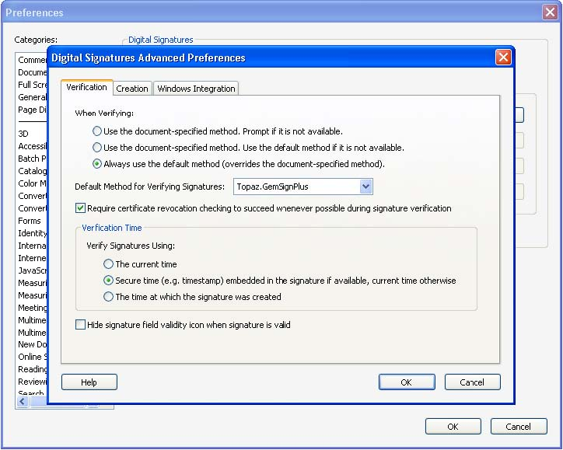
www.topazsystems.com 650 Cochran Street, Unit 6, Simi Valley, CA, USA, 93065 Phone: 805.520.8282; Fax: 805.520.0867
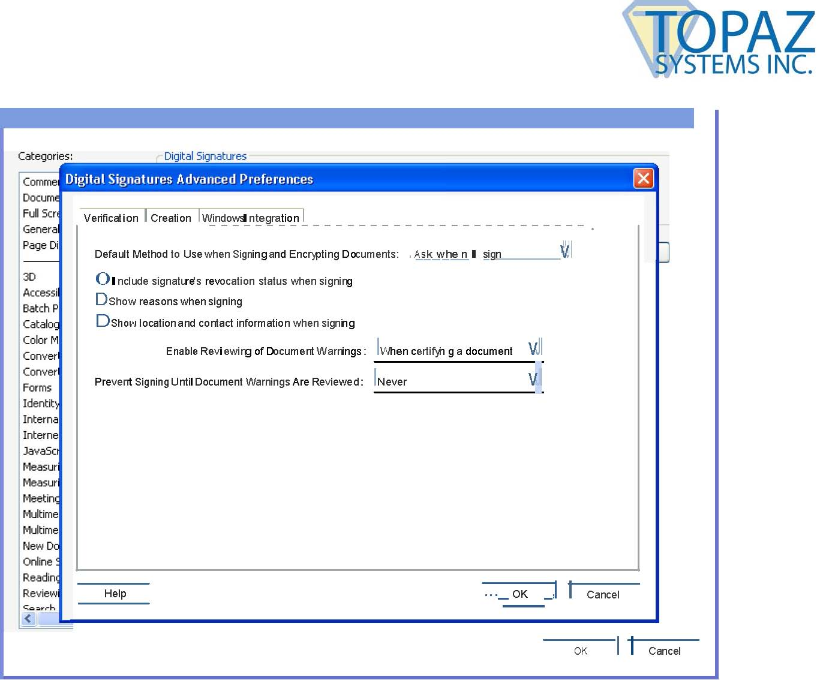
OK Cancel
II
www.topazsystems.com 650 Cochran Street, Unit 6, Simi Valley, CA, USA, 93065 Phone: 805.520.8282; Fax: 805.520.0867

Checking to see if a PDF is Signable in Acrobat Reader
In the majority of cases, a PDF will only be signable in Acrobat Pro and Acrobat Standard. However, in some cases a PDF can be signed in Acrobat Reader. You can check the status of any PDF in Reader by pushing Ctrl+D and then clicking the Security tab. On this tab you will see a list of functions, including Signing, designated as Allowed or Not Allowed.
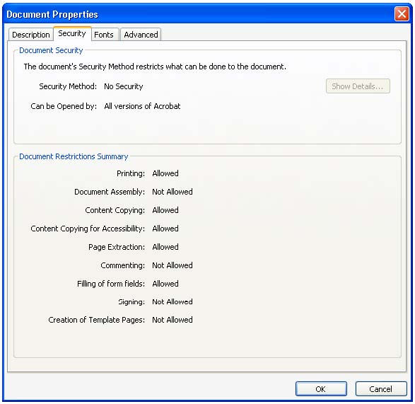
www.topazsystems.com 650 Cochran Street, Unit 6, Simi Valley, CA, USA, 93065 Phone: 805.520.8282; Fax: 805.520.0867

Enable Reader Extensions for a PDF
In Acrobat 8 Pro, click on Advanced along the menu bar, and then click Enable Usage Rights in Adobe Reader. In Acrobat 9 Pro, click on Advanced along the menu bar and then click Extend Features in Adobe Reader.
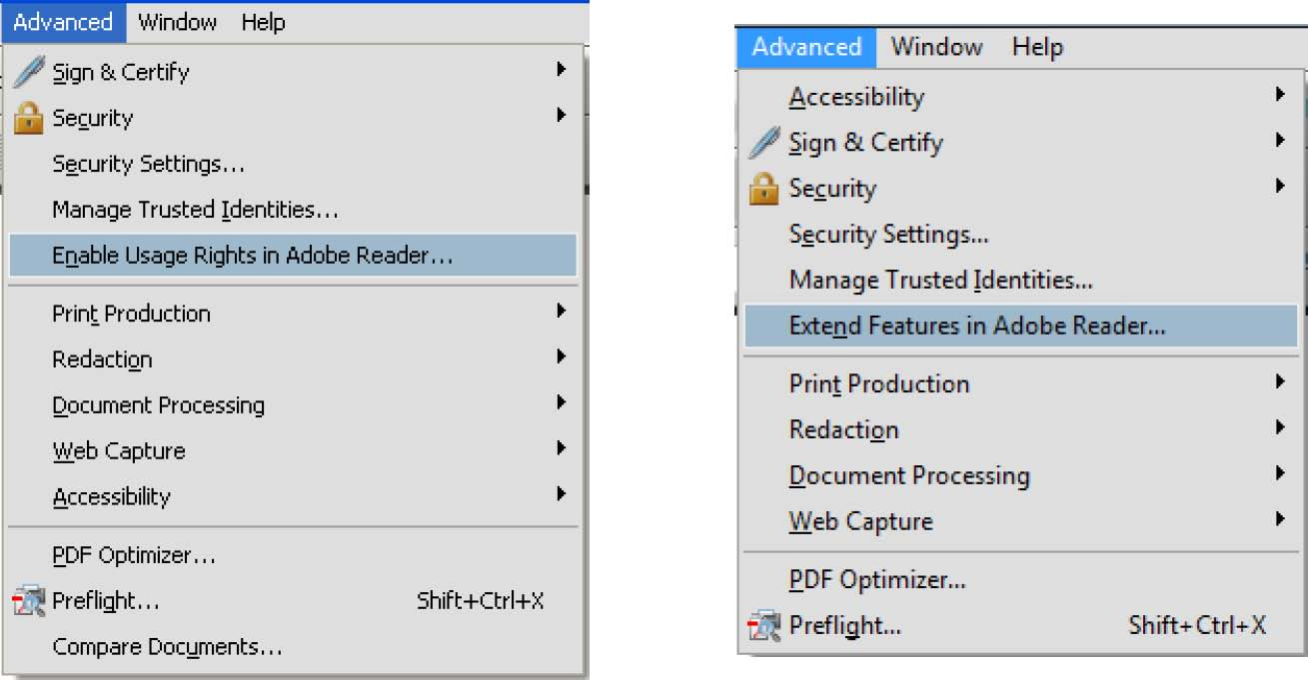
You will then be prompted to save a copy of the PDF that will have Reader Extensions. This copy will be signable in Acrobat Reader.

Signing a PDF
Click the Sign button at the top and choose Place Signature.
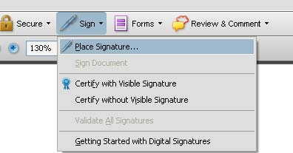
At this point you will be prompted to click and drag a box with your mouse. After doing so, the Signature Capture window will appear.
www.topazsystems.com 650 Cochran Street, Unit 6, Simi Valley, CA, USA, 93065 Phone: 805.520.8282; Fax: 805.520.0867
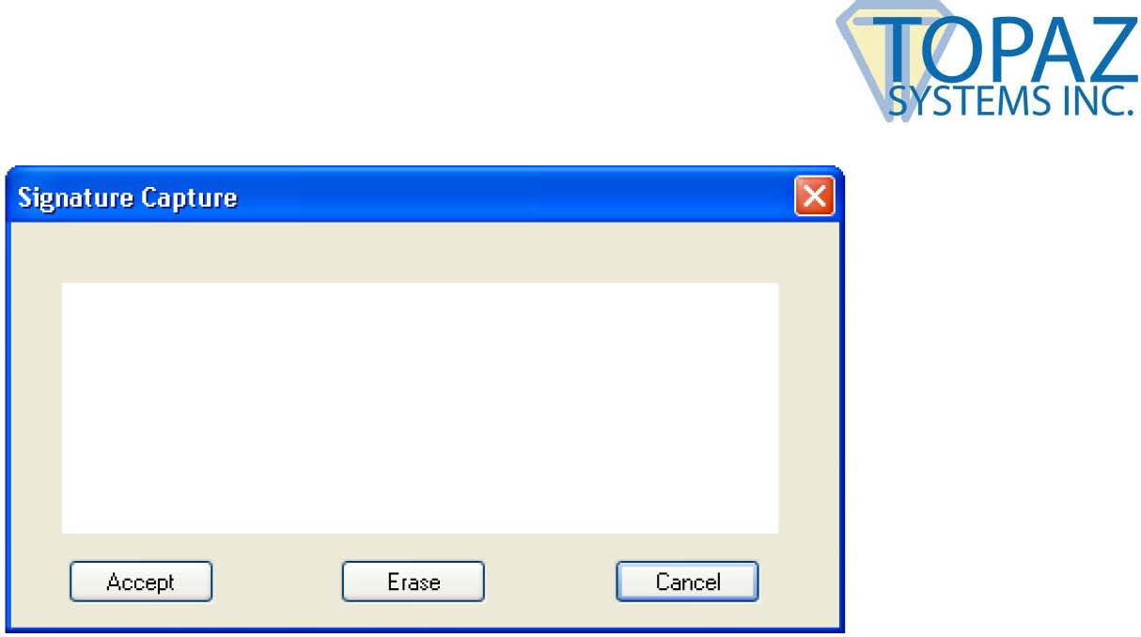
When you are finished signing, click Accept and the signature will be embedded into the PDF. The PDF will save during the signing process. This save will either occur automatically or pull up a Save As window depending on how your GemSignPdf.ini is configured. The default setting is for an automatic save.

Signing an Existing Signature Field
An existing blank signature field will show in a PDF as a red tag. When mousing over a blank signature field the mouse cursor will change from an open hand to a hand with a pointing finger. Click on the signature field and the Signature Capture window will appear. When you are finished signing, click Accept and the signature will be embedded into the PDF.
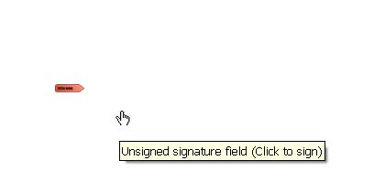
www.topazsystems.com 650 Cochran Street, Unit 6, Simi Valley, CA, USA, 93065 Phone: 805.520.8282; Fax: 805.520.0867

Options for Existing Signatures
Clicking on a signature shows you its validity status.
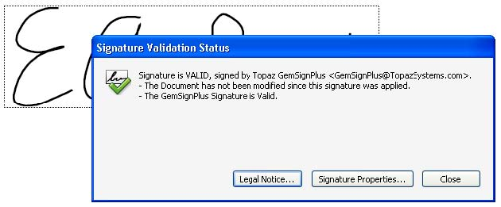
Right-clicking on a signature allows you to clear it.
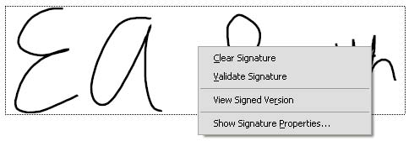
If the PDF is changed after the signature has been applied, you can always choose to view the signed version from the right-click menu.
www.topazsystems.com 650 Cochran Street, Unit 6, Simi Valley, CA, USA, 93065 Phone: 805.520.8282; Fax: 805.520.0867

The GemSignPdf.ini File
The GemSignPDF.ini is located by default in C:\Windows.
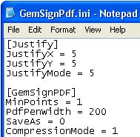
There are two sections in the GemSignPdf.ini. The first is [Justify].
- JustifyX -This command sets a buffer in pixels from each side in the signature field. It will create a zone at the edge of the field where the signature will be excluded.
- JustifyY – This command sets a buffer in pixels from the top and bottom in the signature field. It will create a zone at the edge of the field where the signature will be excluded.
- JustifyMode -This sets the justification, which is where the signature is going to be displayed in the signature field. 0 is center, and 5 is justify and zoom signature (center of control).

The second section is [GemSignPDF].
- MinPoints -This sets the minimum points required to have a valid signature. If your signature does not meet this minimum, the Signature Capture window will close when you click Accept, but no signature will be embedded into the PDF.
- PdfPenWidth -This sets the thickness of the ink displayed in the PDF in pixels. Modify this in increments of 100.
- SaveAs -When set to 0, Acrobat automatically saves after signing. When set to 1, Acrobat prompts a Save As after signing.
- CompressionMode -Used to shrink the size (in data) of the signature being added to the PDF. When set to 1, a lossless compression will be applied. When set to 2, a certain percentage of signature points are removed from the signature. Use only 0 (for uncompressed), 1, or 2.

www.topazsystems.com 650 Cochran Street, Unit 6, Simi Valley, CA, USA, 93065 Phone: 805.520.8282; Fax: 805.520.0867

